WATER QUALITY REPORT CARD – SUMMARY TABLE
2020 Status or  Long-Term Trend | 2020 Mean Secchi Depth | Long-Term Secchi Depth Trend | 2020 Mean Chlorophyll-a | Long-Term Chlorophyll-a Trend | 2020 Mean Total Phosphorus | Long-Term Total Phosphorus Trend
Improving (# of lake sites) | 31 | 12 | 4 | 5 | 8 | 4
No Trend (# of lake sites) | 5 | 32 | 0 | 43 | 0 | 30
Deteriorating (# of lake sites) | 17 | 9 | 20 | 5 | 16 | 16
Insufficient Data (# of lake sites) | 19 | 19 | 3 | 19 | 3 | 22
Total (# of lake sites) | 72 | 72 | 27 | 72 | 27 | 72

WATER QUALITY REPORT CARD – DETAILED TABLE
Lake Site (highlighted lakes have internal phosphorus loading influencing samples) | Lake Area (acres) | 2020 Mean Secchi Depth (m) | Long-Term Mean Secchi Depth (m) | Long-Term Secchi Depth Trend | 2020 Mean Chlorophyll-a (ug/l) | Long-Term Mean Chlorophyll-a (ug/l) | Long-Term Chlorophyll-a Trend | 2020 Mean Total Phosphorus (ug/l) | Long-Term Mean Total Phosphorus (ug/l) | Long-Term Total Phosphorus Trend
BEEBE (HUBDTN) | 112.4 | 7.1 | 7 | Deteriorating | NA | 3.1 | No Trend | NA | 13.1 | No Trend
BERLIN | 289.6 | 7.1 | 7.4 | Insufficient Data | NA | NA | Insufficient Data | NA | NA | Insufficient Data
BOMOSEEN | 2415.1 | 9.2 | 7.4 | Improving | NA | 1.6 | No Trend | NA | 12.4 | Deteriorating
BROWNINGTON | 137.5 | 2.9 | 3 | Insufficient Data | NA | NA | Insufficient Data | NA | NA | Insufficient Data
CARMI | 1415.2 | 1.8 | 2.1 | Improving | 45 | 17.3 | No Trend | 35.1 | 31 | No Trend
CASPIAN | 789.8 | 8.4 | 7.7 | No Trend | 3.6 | 2.1 | No Trend | 11.3 | 10.9 | Deteriorating
Champlain #10 (Outer Malletts Bay) | 13591.3 | 4.2 | 4.7 | Deteriorating | NA | 3.6 | No Trend | NA | 12.9 | No Trend
Champlain #11 (Inner Malletts Bay) | 13591.3 | 4 | 4.6 | Deteriorating | NA | 3.7 | No Trend | NA | 12.4 | Deteriorating
Champlain #29 (Inner Carry Bay) | 57635.1 | 3.1 | 3 | No Trend | NA | 7.9 | Deteriorating | NA | 30.4 | Deteriorating
Lake Site (highlighted lakes have internal phosphorus loading influencing samples) | Lake Area (acres) | 2020 Mean Secchi Depth (m) | Long-Term Mean Secchi Depth (m) | Long-Term Secchi Depth Trend | 2020 Mean Chlorophyll-a (ug/l) | Long-Term Mean Chlorophyll-a (ug/l) | Long-Term Chlorophyll-a Trend | 2020 Mean Total Phosphorus (ug/l) | Long-Term Mean Total Phosphorus (ug/l) | Long-Term Total Phosphorus Trend
Champlain #30 (Alburg Bridge) | 8482.2 | 2 | 2 | Deteriorating | NA | 14 | Deteriorating | NA | 43.5 | Deteriorating
Champlain #37 (Outer Carry Bay) | 20882.2 | 4.7 | 4 | No Trend | NA | 6.1 | No Trend | NA | 20.5 | No Trend
Champlain #38 (Town Farm Bay) | 5179.7 | 3.1 | 2.7 | No Trend | NA | 7.9 | No Trend | NA | 25.5 | No Trend
Champlain #40 (Burlington - North Beach) | 3296.9 | 4.9 | 4.5 | No Trend | NA | 5.1 | No Trend | NA | 16.6 | No Trend
Champlain #41 (Queneska Island) | 40368.2 | 4.4 | 4.3 | No Trend | NA | 4.9 | No Trend | NA | 15.9 | No Trend
CHIPMAN | 79.6 | 3 (hits bottom) | 3 (hits bottom) | Insufficient Data | NA | 3 | No Trend | NA | 12.9 | Deteriorating
CHITTENDEN | 748 | 4.8 | 4.3 | Insufficient Data | NA | NA | Insufficient Data | NA | NA | Insufficient Data
COLE | 41.4 | 3 (hits bottom) | 3 (hits bottom) | Insufficient Data | 4.1 | 2.4 | Deteriorating (No Trend in 2019) | 10.4 | 9.4 | No Trend
COLES | 106.8 | 3.6 | 3.4 | No Trend | NA | 3 | No Trend | NA | 10.2 | No Trend
COW MOUNTAIN | 9.4 | 3.1 | NA | Insufficient Data | NA | NA | Insufficient Data | NA | NA | Insufficient Data
CRYSTAL (BARTON) | 771.6 | 6.7 | 7.9 | No Trend | NA | 1.7 | No Trend | NA | NA | Insufficient Data
CURTIS | 76.2 | 5.2 | 4.9 | Improving | NA | 7.3 | No Trend | NA | 18.3 | No Trend
DUNMORE | 1039.6 | 5.7 | 6.1 | Deteriorating | 4 | 3.4 | No Trend | 12.9 | 12.8 | Deteriorating
ECHO (CHARTN) | 546.5 | 7.5 | 7.8 | No Trend | 2.7 | 1.7 | No Trend | 12.7 | 9.6 | Deteriorating
EDEN | 198 | 3.6 | 4.1 | No Trend | 4.7 | 3.6 | No Trend | 11.9 | 11.7 | Deteriorating
ELMORE | 222.3 | 2.8 | 3 | No Trend | 4.8 | 4 | Improving | 16.4 | 15 | No Trend
FAIRLEE | 461.8 | 6.3 | 6.1 | Deteriorating | 6.6 | 4.7 | No Trend | 23.4 | 15.6 | Deteriorating
Lake Site (highlighted lakes have internal phosphorus loading influencing samples) | Lake Area (acres) | 2020 Mean Secchi Depth (m) | Long-Term Mean Secchi Depth (m) | Long-Term Secchi Depth Trend | 2020 Mean Chlorophyll-a (ug/l) | Long-Term Mean Chlorophyll-a (ug/l) | Long-Term Chlorophyll-a Trend | 2020 Mean Total Phosphorus (ug/l) | Long-Term Mean Total Phosphorus (ug/l) | Long-Term Total Phosphorus Trend
FERN | 67.3 | 7.4 | 6.2 | Improving | NA | 7.1 | Insufficient Data | NA | 17.5 | Insufficient Data
GILLETT | 31 | 0.9 (hits bottom) | NA (hits bottom) | Insufficient Data | NA | 2.1 | Insufficient Data | NA | 15.6 | Insufficient Data
GOULDS (MUCKROSS) | 5.9 | 1.6 | 1.7 | Insufficient Data | NA | 6.9 | Insufficient Data | NA | 29 | Insufficient Data
GREAT HOSMER | 146.5 | 6.1 | 5.5 | Improving | NA | 8.8 | No Trend | NA | 22.6 | No Trend
GREENWOOD | 91.5 | 6.2 | 5.5 | Improving | NA | 6.2 | No Trend | NA | 17.4 | No Trend
GROTON | 435.4 | 4.4 | 3.6 | No Trend (Deteriorating in 2019) | 3.8 | 4.1 | No Trend | 11.8 | 13 | No Trend
HARVEYS | 357.2 | 6.1 | 5.8 | No Trend | NA | 2.8 | Improving | NA | 12.7 | No Trend
HIGH (SUDBRY) | 17.5 | 6.8 | 7 | Insufficient Data | 4 | 4.9 | Insufficient Data | 18.5 | 20.3 | Insufficient Data
HOLLAND | 329.1 | 2.8 | 3 | No Trend | NA | 3.5 | No Trend | NA | 9.5 | No Trend
HORTONIA | 500.9 | 4.3 | 5.3 | Improving | NA | 4.4 | No Trend | NA | 15.8 | Insufficient Data
INDIAN BROOK (ESSEX) | 57.5 | 4.3 | 4 | No Trend | NA | 11.4 | No Trend | NA | 19.8 | No Trend
IROQUOIS | 247 | 3.8 | 3.8 | No Trend | 13.5 | 10.7 | No Trend | 17.8 | 25 | Improving
JOES (DANVLL) | 405 | 4.6 | 4.5 | No Trend | 5.7 | 3 | No Trend | 12.4 | 18.9 | Improving
KNAPP BROOK #1 | 27.2 | 1.4 | 1.3 | Insufficient Data | NA | NA | Insufficient Data | NA | NA | Insufficient Data
KNAPP BROOK #2 | 32 | 1.6 | 1.6 | Insufficient Data | NA | NA | Insufficient Data | NA | NA | Insufficient Data
LITTLE (WELLS) | 179 | 1.5 (hits bottom) | NA | Insufficient Data | 6.4 | 3 | No Trend | 19.3 | 16.2 | No Trend
LOWELL | 93.4 | 4.2 | 4 | No Trend | NA | 3.7 | No Trend | NA | 12 | No Trend
MAIDSTONE | 755.8 | 10.9 | 9.6 | Improving | 1.7 | 1.6 | Improving | 8 | 6.8 | Deteriorating
Lake Site (highlighted lakes have internal phosphorus loading influencing samples) | Lake Area (acres) | 2020 Mean Secchi Depth (m) | Long-Term Mean Secchi Depth (m) | Long-Term Secchi Depth Trend | 2020 Mean Chlorophyll-a (ug/l) | Long-Term Mean Chlorophyll-a (ug/l) | Long-Term Chlorophyll-a Trend | 2020 Mean Total Phosphorus (ug/l) | Long-Term Mean Total Phosphorus (ug/l) | Long-Term Total Phosphorus Trend
MARTINS | 80.4 | 3.7 | 3.4 | Insufficient Data | NA | 2.5 | Insufficient Data | NA | NA | Insufficient Data
MEMPHREMAGOG | 5929.3 | 3.4 | 3.6 | No Trend (Deteriorating in 2019) | 7.1 | 4.8 | No Trend | 17.8 | 19.2 | No Trend
MIRROR | 87.8 | 6.9 | 7.9 | No Trend | 4.9 | 3.3 | No Trend | 16.2 | 15.3 | No Trend
MOREY | 549.8 | 6 | 6.4 | No Trend | 7.4 | 6.4 | No Trend | 24.1 | 21.3 | Deteriorating
NEWARK | 158.2 | 6.7 | 6 | No Trend | 3.3 | 2.6 | No Trend | 10.6 | 9.5 | No Trend
NICHOLS | 167.5 | 6.8 | 7.3 | No Trend | NA | 5.9 | No Trend | NA | 11.6 | No Trend
NORTON | 658.6 | 3 | 3.3 | Insufficient Data | NA | NA | Insufficient Data | NA | NA | Insufficient Data
PEACHAM | 347.4 | 5.4 | 4.5 | No Trend (Deteriorating in 2019) | NA | 3.9 | No Trend | NA | 13.8 | No Trend
PERCH (BENSON) | 25.1 | 8.1 | 7.3 | Improving | NA | 2.5 | Insufficient Data | NA | NA | Insufficient Data
RAPONDA | 123.8 | 3.4 (hits bottom) | 3.4 (hits bottom) | No Trend | 5 | 2.6 | No Trend | 11.2 | 11.4 | Improving
RESCUE | 189.2 | 4.8 | 4.1 | No Trend | NA | 4.1 | No Trend | NA | 11.6 | No Trend
RUNNEMEDE | 62.8 | 2.9 (hits bottom) | 3.1 (hits bottom) | Insufficient Data | NA | 2.8 | Deteriorating | NA | 15.7 | Deteriorating
SABIN (WOODBURY) | 147.5 | 5.3 | 4.8 | No Trend | NA | 4.5 | No Trend | NA | 10.4 | Insufficient Data
SALEM | 776.4 | 4.6 | 4.6 | No Trend | 4.3 | 3 | Deteriorating | 18.3 | 14.4 | Deteriorating
SEYMOUR | 1777.2 | 8.3 | 8.1 | Deteriorating | 2 | 2.2 | Improving | 8.8 | 8.9 | No Trend
SHADOW (GLOVER) | 217.3 | 9.9 | 7.9 | Improving | 2.2 | 2.3 | No Trend | 9.4 | 8.9 | Deteriorating
SOUTH (MARLBR) | 68.5 | 4.1 | 4.4 | No Trend | NA | NA | Insufficient Data | NA | NA | Insufficient Data
SOUTH BAY (MEMPHREMAGOG) | 709.7 | 3.4 | 1.7 | Insufficient Data | 7.1 | 6.8 | Insufficient Data | 17.8 | 22.9 | Insufficient Data
Lake Site (highlighted lakes have internal phosphorus loading influencing samples) | Lake Area (acres) | 2020 Mean Secchi Depth (m) | Long-Term Mean Secchi Depth (m) | Long-Term Secchi Depth Trend | 2020 Mean Chlorophyll-a (ug/l) | Long-Term Mean Chlorophyll-a (ug/l) | Long-Term Chlorophyll-a Trend | 2020 Mean Total Phosphorus (ug/l) | Long-Term Mean Total Phosphorus (ug/l) | Long-Term Total Phosphorus Trend
SPRING (SHRWBY) | 63.7 | 10.2 | 7.1 | No Trend | NA | 11 | No Trend | NA | 14.3 | No Trend
ST. CATHERINE | 885.4 | 5.1 | 5.1 | Deteriorating | 5 | 4.2 | No Trend | 14.6 | 14.9 | No Trend
STRATTON | 48 | 2.4 | 2.1 | No Trend | NA | 7.4 | Improving | NA | 10.9 | Deteriorating
SUNRISE | 61.3 | 7.1 | 7.3 | Deteriorating | NA | 2 | Insufficient Data | NA | NA | Insufficient Data
SUNSET (MARLBR) | 97.6 | 5 | 5.4 | Insufficient Data | NA | NA | Insufficient Data | NA | NA | Insufficient Data
TICKLENAKED | 55 | 2 | 2.4 | Improving | 8 | 14 | No Trend | 35.9 | 28.3 | Improving
VALLEY | 92.3 | 7.5 | 6.9 | Improving | NA | 7.1 | No Trend | NA | 31.1 | No Trend
WALLINGFORD | 88.2 | 2.4 | 2.4 | Insufficient Data | 3.9 | 3.9 | Insufficient Data | 14.5 | 14.5 | Insufficient Data
WILLOUGHBY | 1863.9 | 9.6 | 8 | No Trend | 2.5 | 1.4 | No Trend | 7.7 | 10.6 | No Trend (Deteriorating in 2019
WOLCOTT | 72.6 | 2.2 | 2.4 | Insufficient Data | NA | NA | Insufficient Data | NA | NA | Insufficient Data

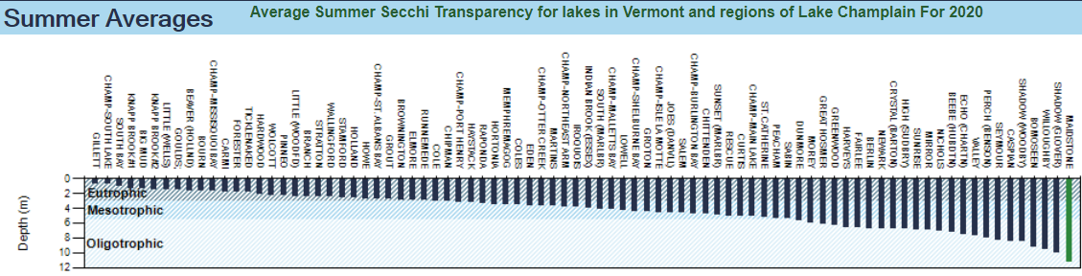
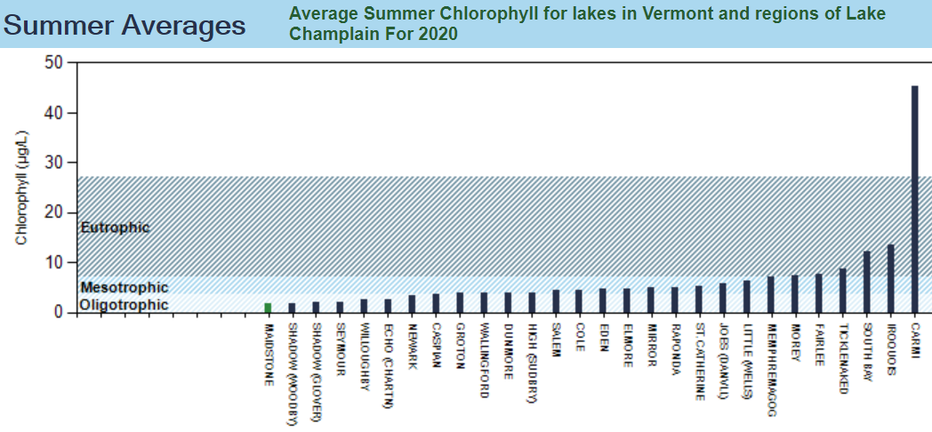
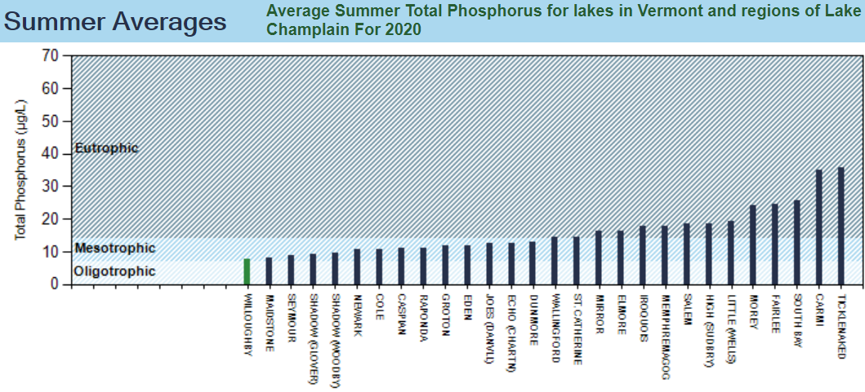
National Oceanic and Atmospheric Administration (NOAA) Online Weather Data for Vermont:

